Name: Sreevatsa Nukala
Batch: LISUM15
Submission Date: 11/27/2022
Submitted to: https://github.com/Sreevatsa03/flask-tutorial

Heroku Deployment
1.Model Creation
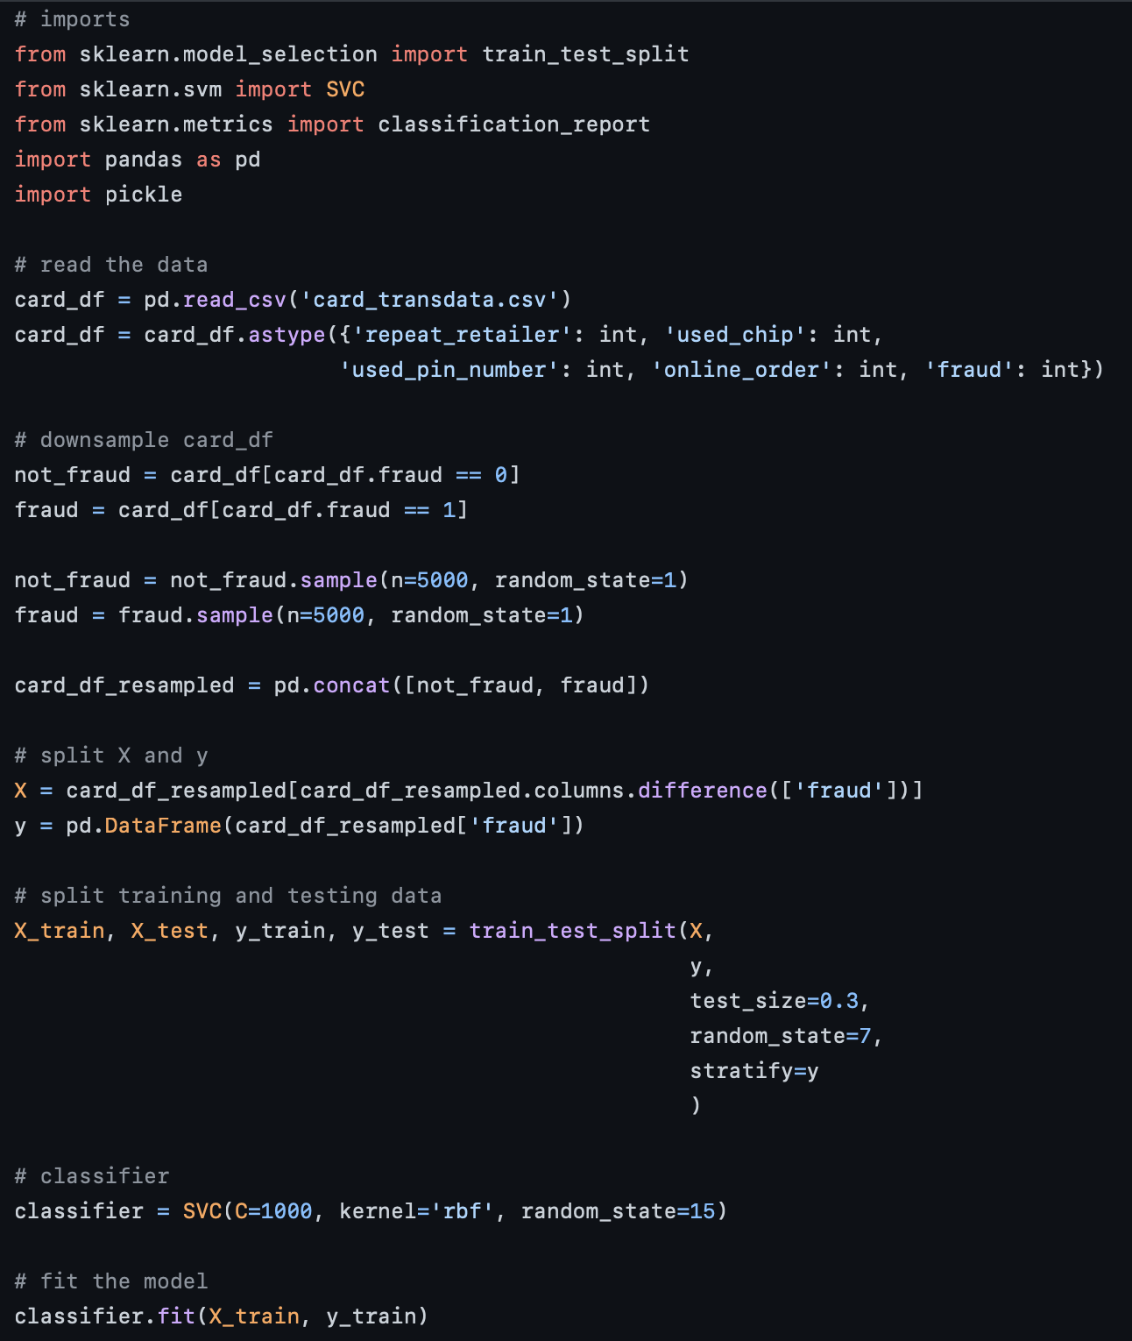
2. Flask App Creation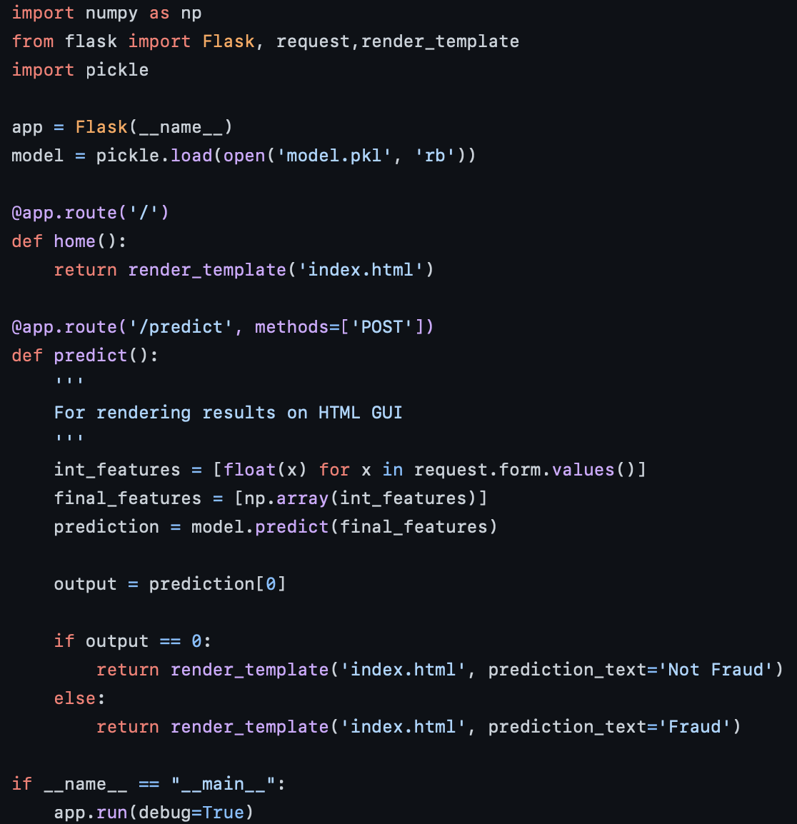

3. Procfile
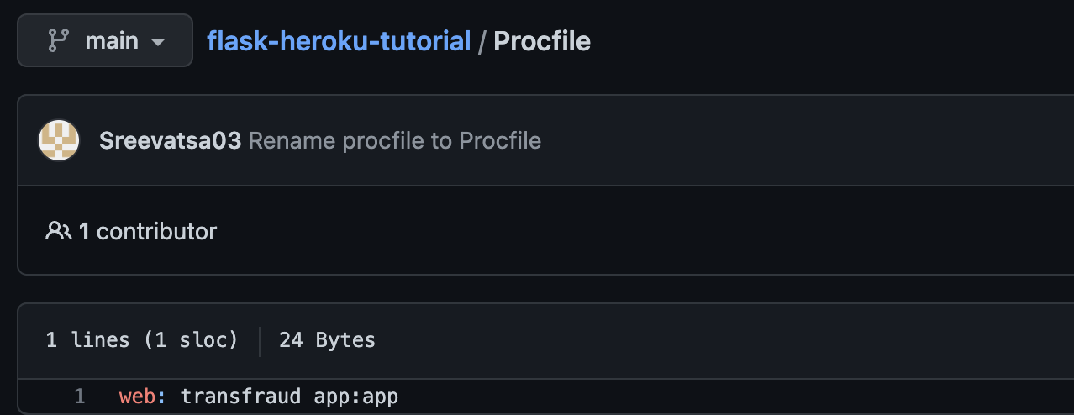
4. Heroku App Deployment
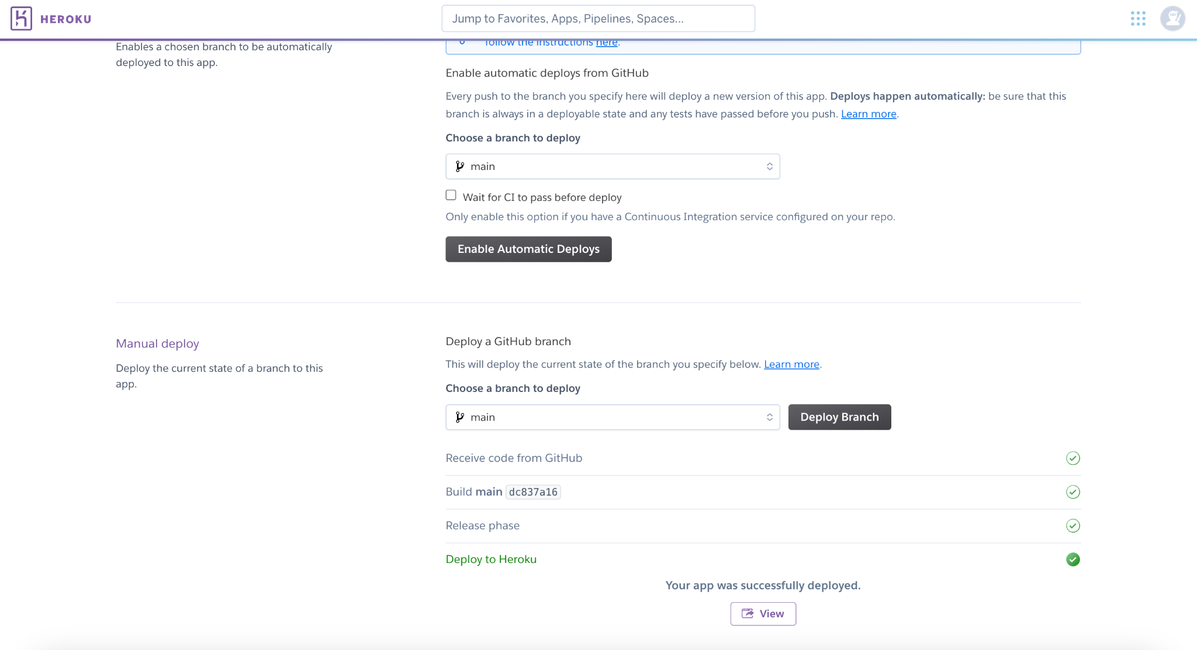

5. Link
https://transaction-fraudulence.herokuapp.com/

6. Usage
